**Analysis Phase**

**Data Flow Diagrams (DFD)**

Structure modeling is used the structured analysis and is also called data flow diagram **(DFD)** molding. **Microsoft Visio** is the most widely used **CASE** tools to draw the **DFD.** 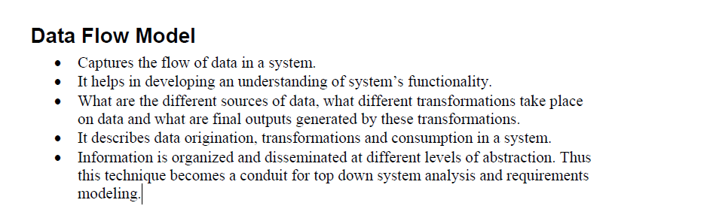

There are two main standard to followed for structure modeling.

* Gane & Sarson data
* Demarco & Yourdon

Both model were introduced in 1979. There is no difference between the models except the modeling symbols/notations.

We follow the Demarco & Yourdon model and their modeling symbol are as follow.

**Process Notation Entity**

External Interactor

Data Store

**Data Flow**

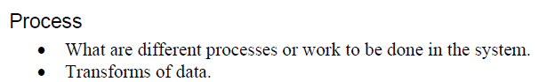

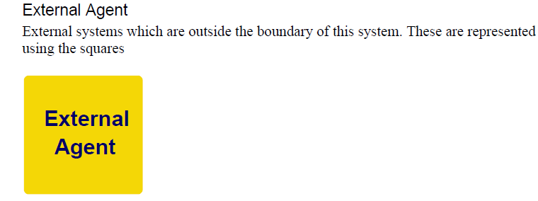

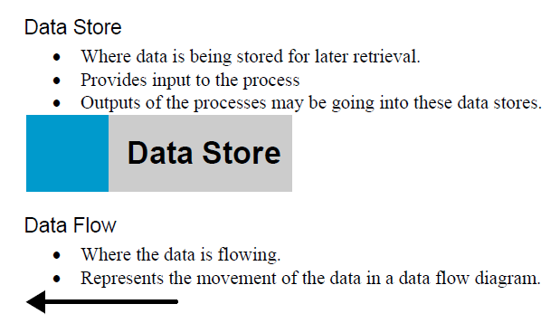

**Rules to Draw Structure Modeling**

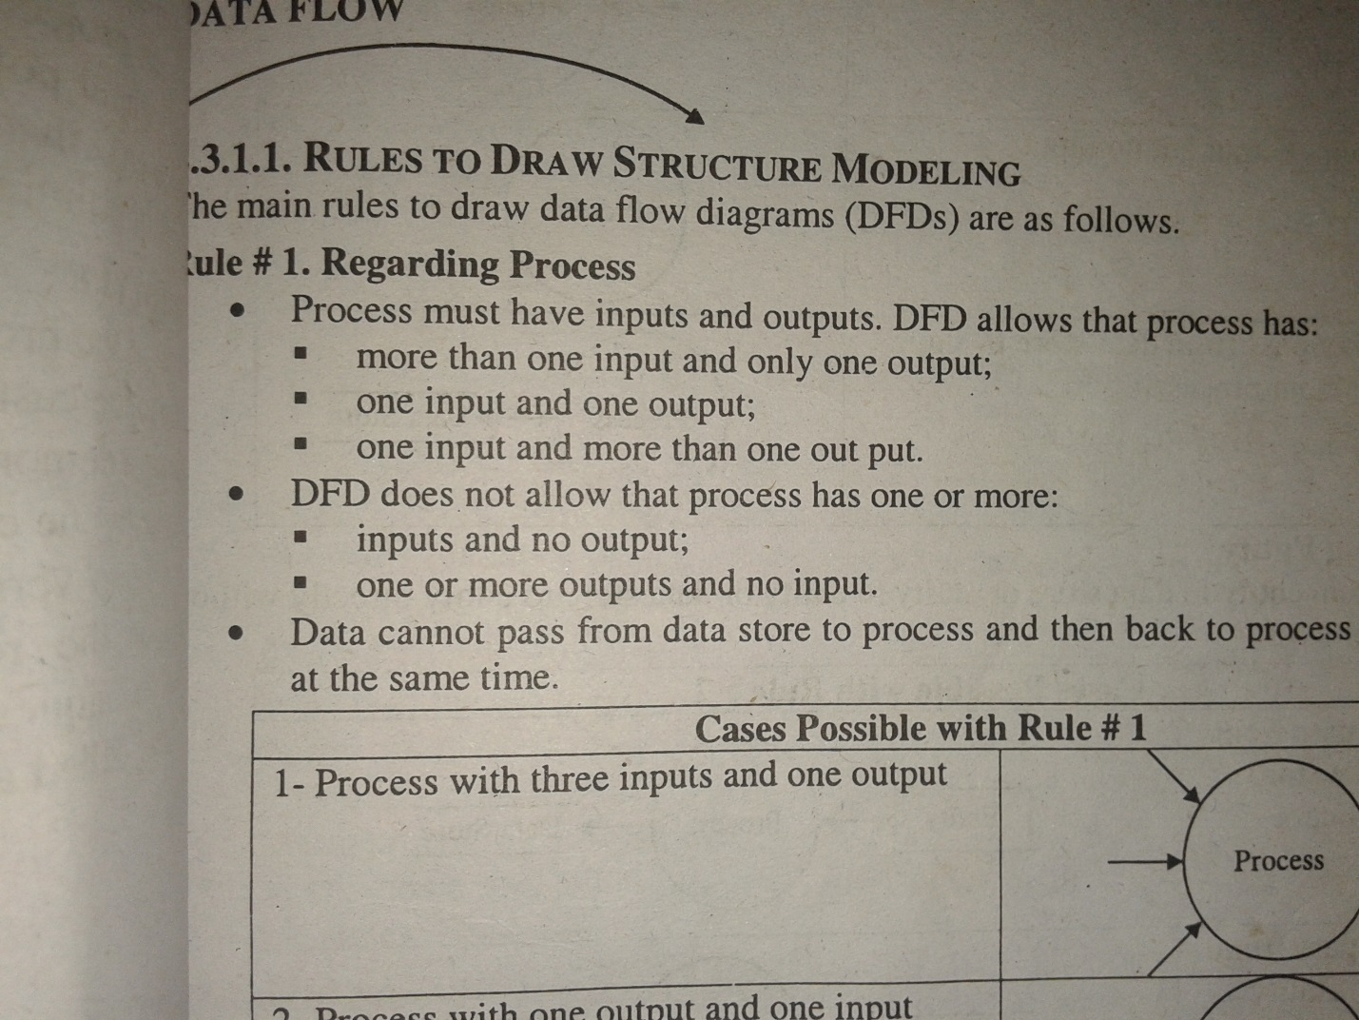

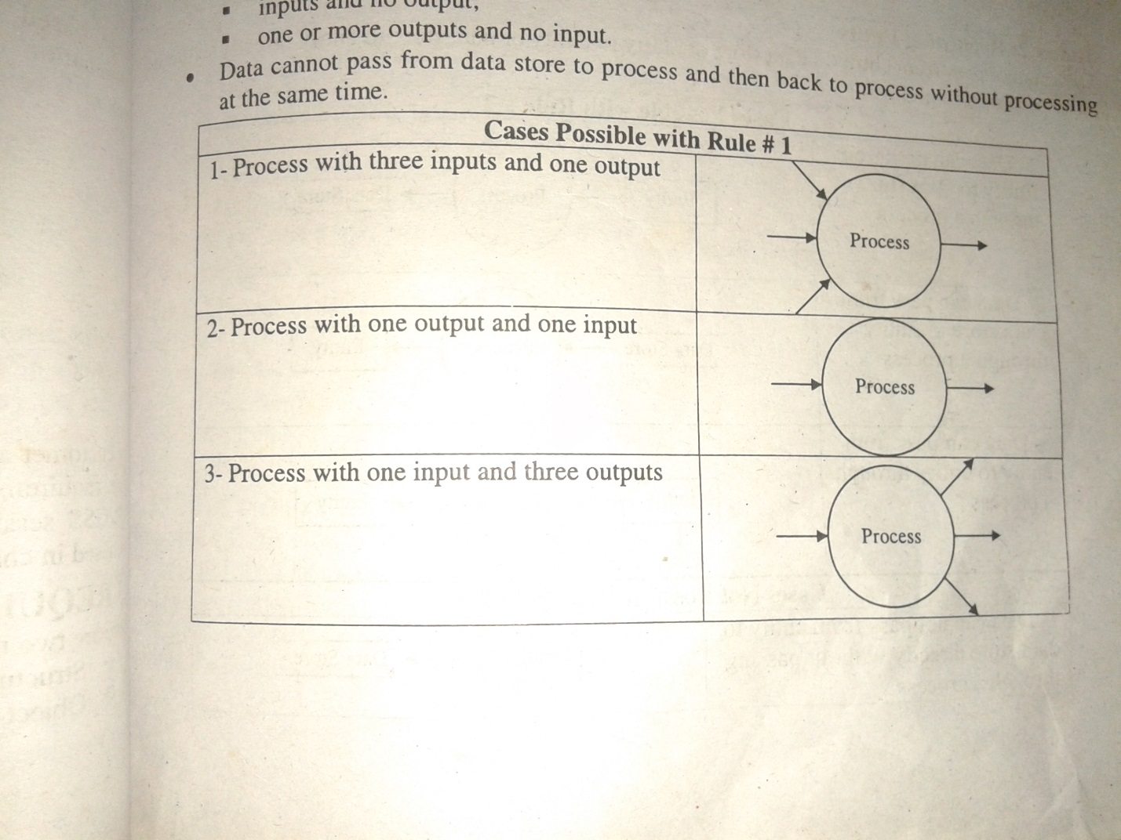

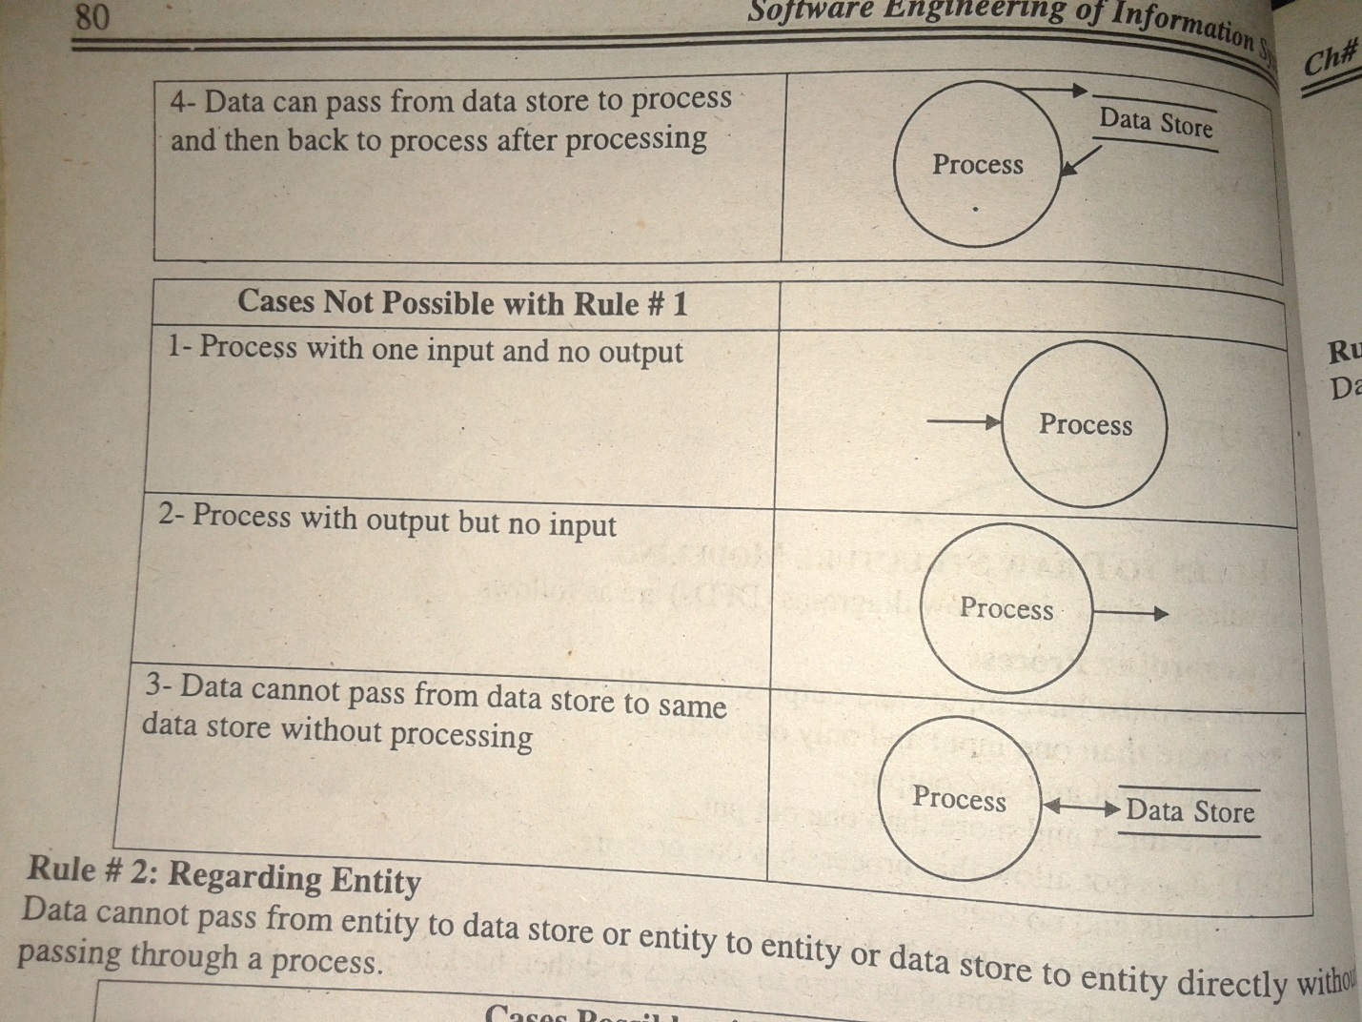

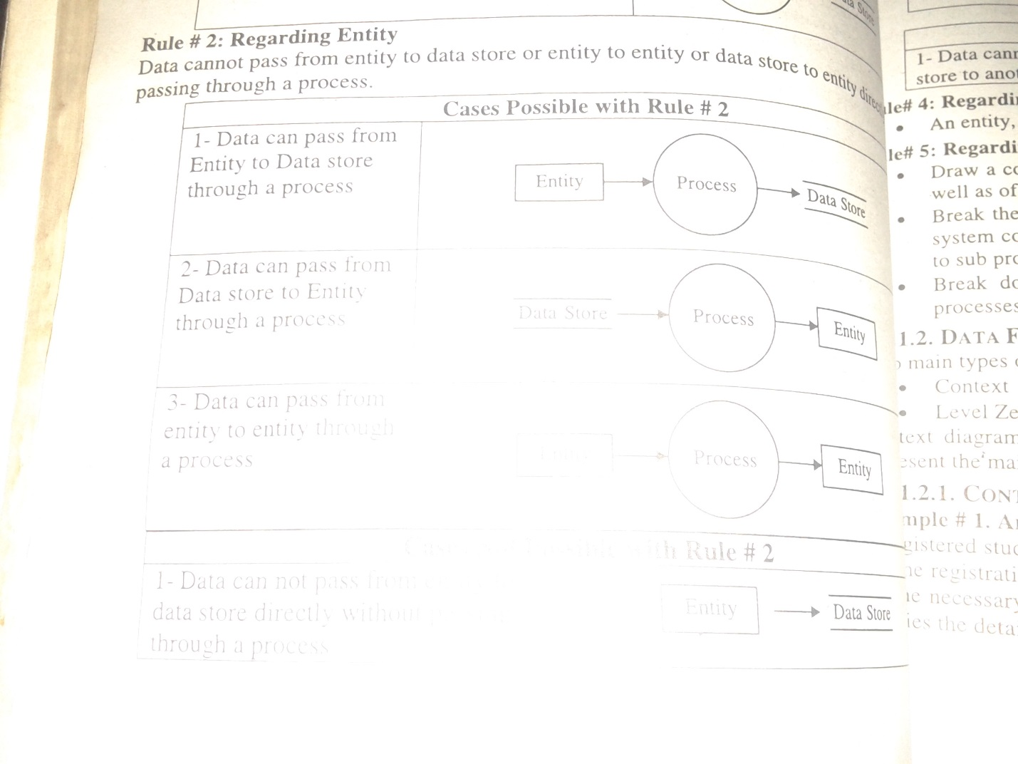

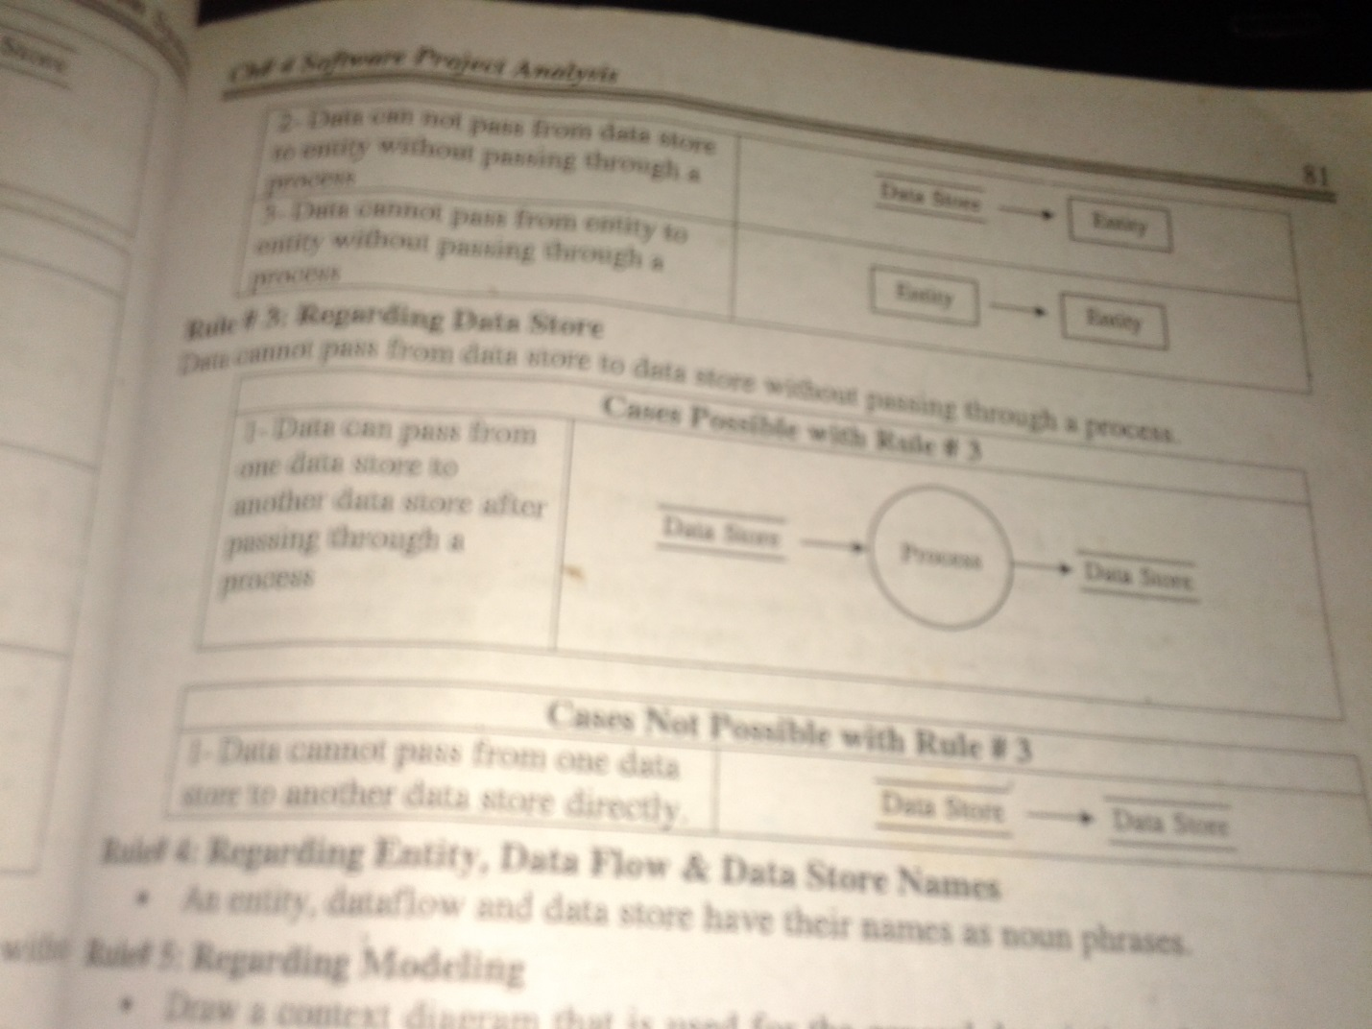

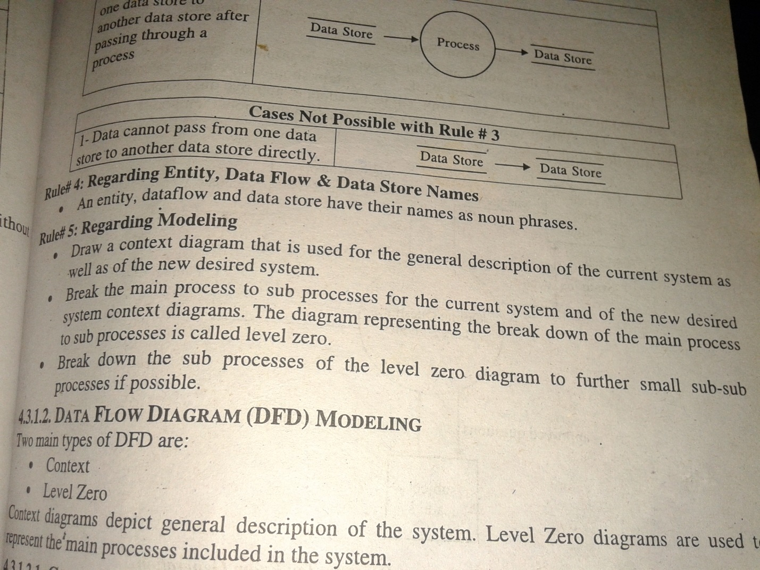

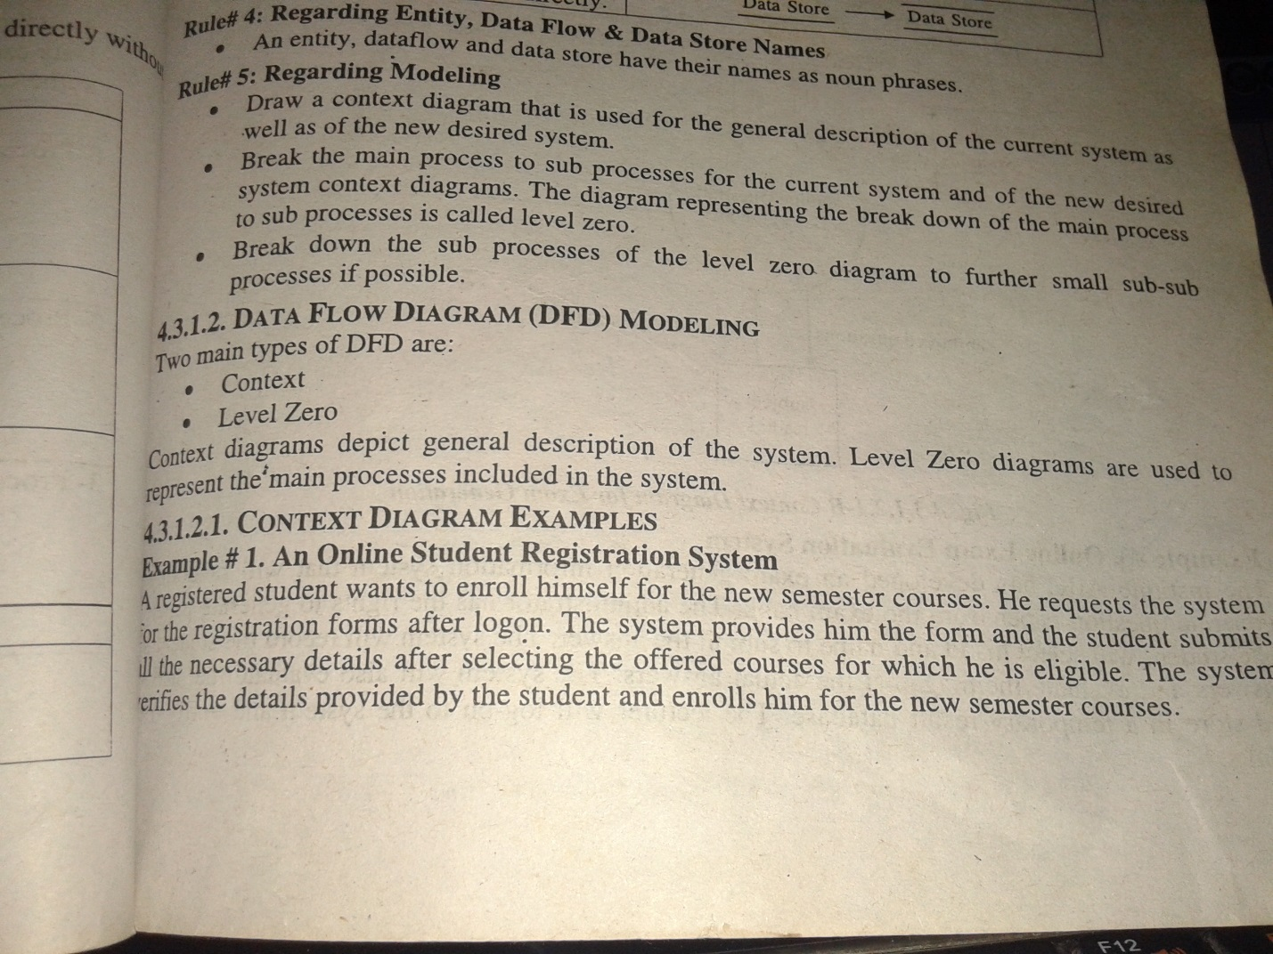

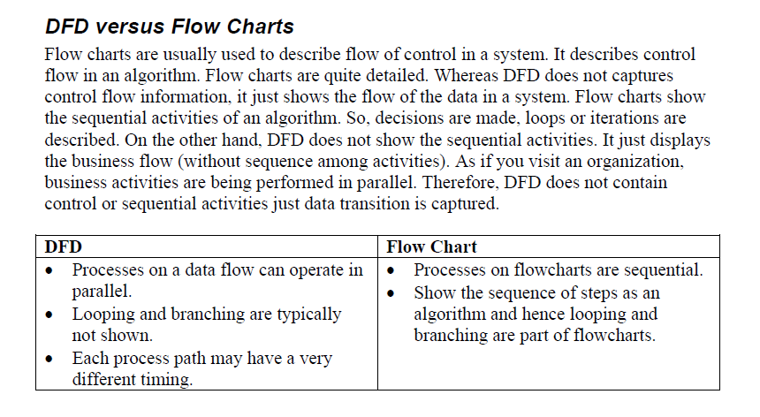

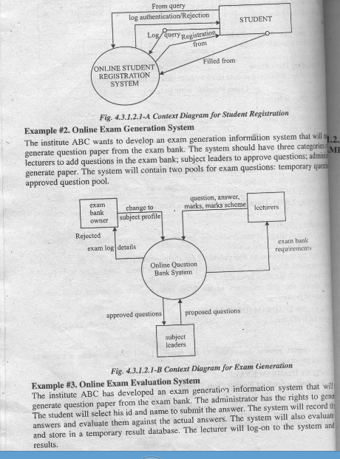

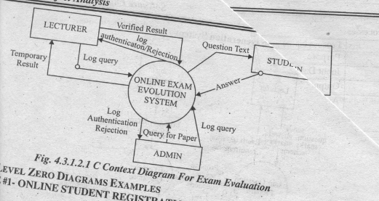

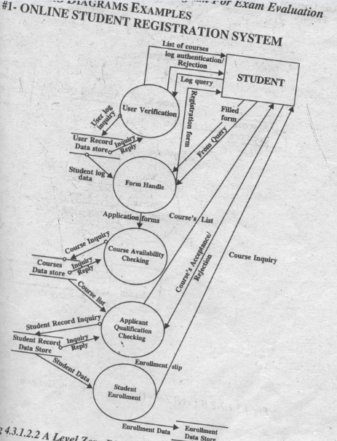

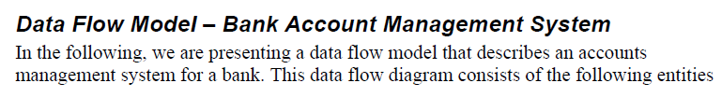

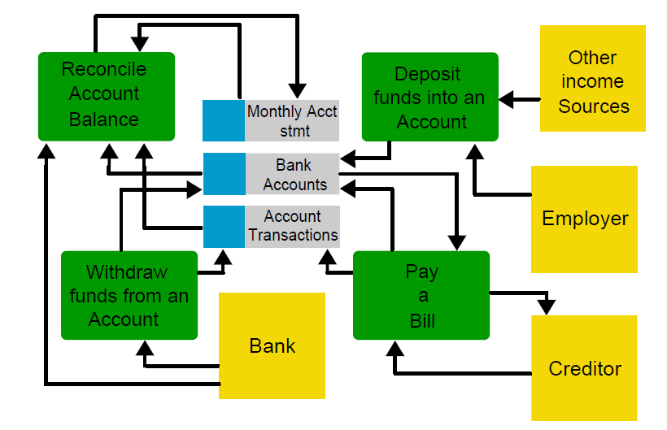

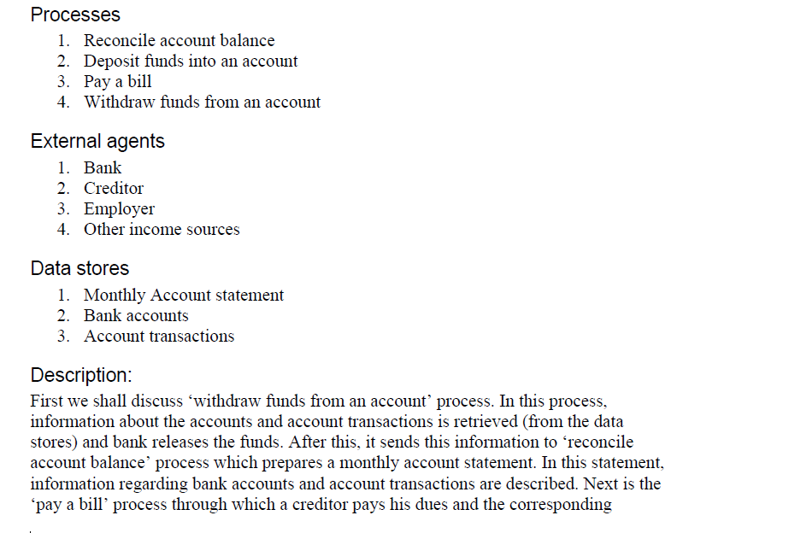

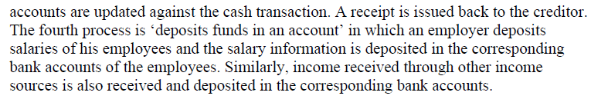

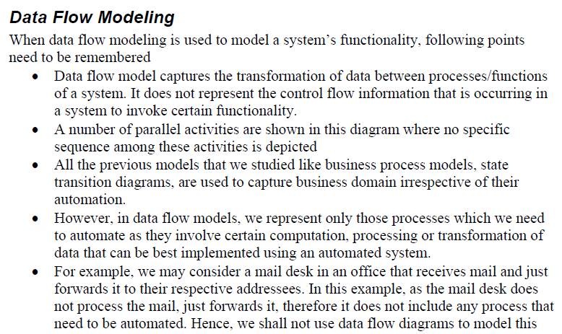

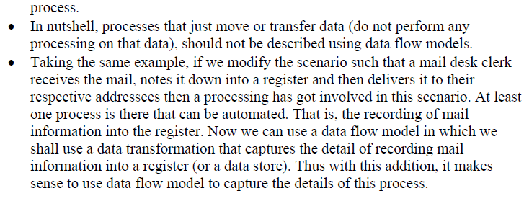

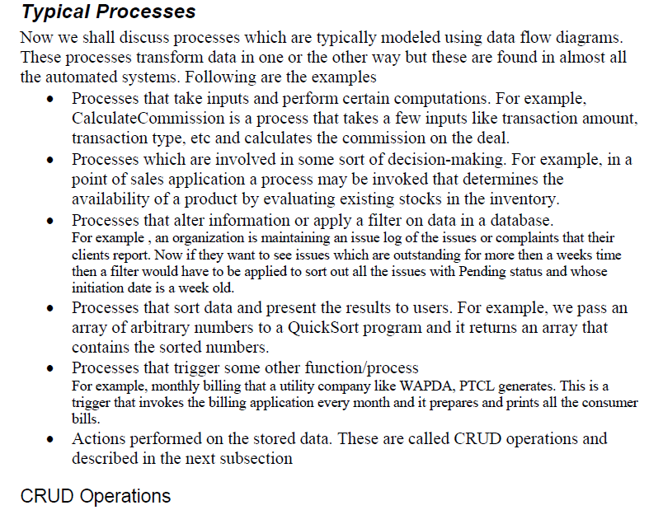

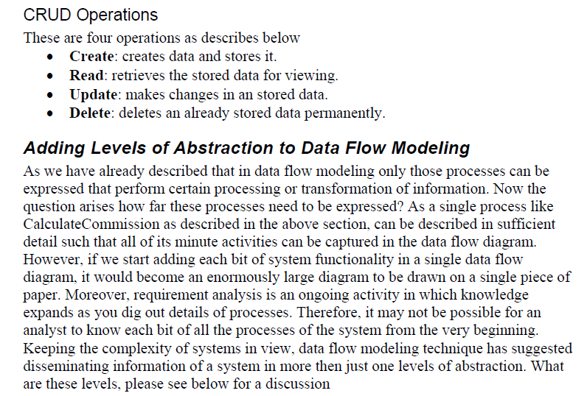

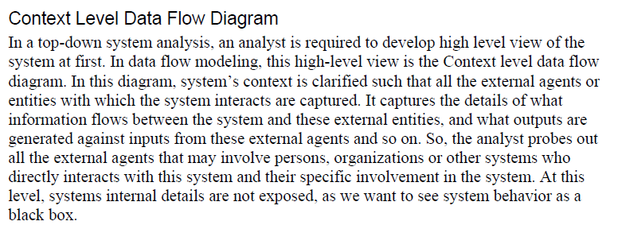

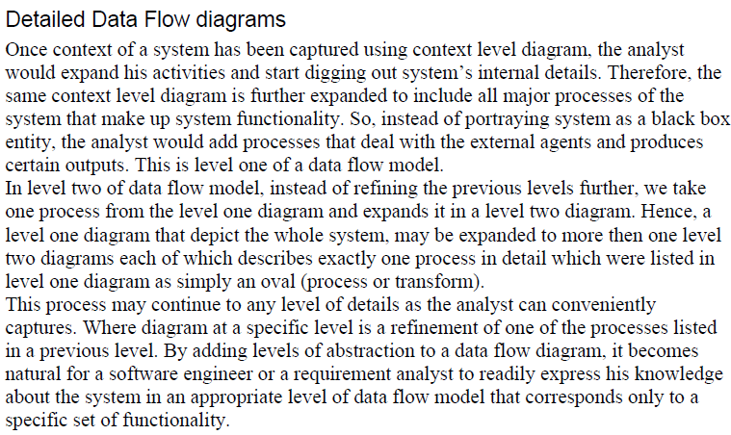

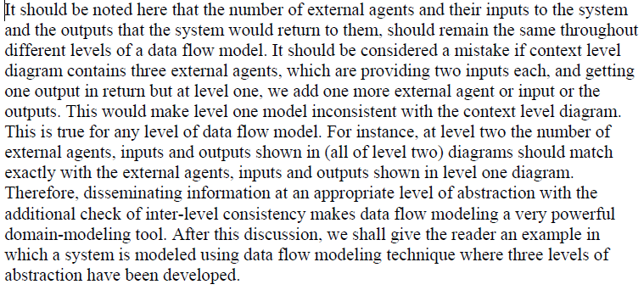

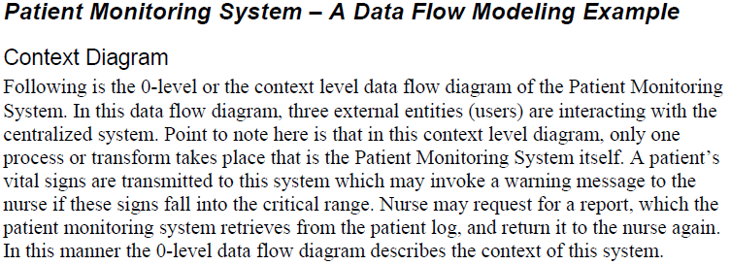

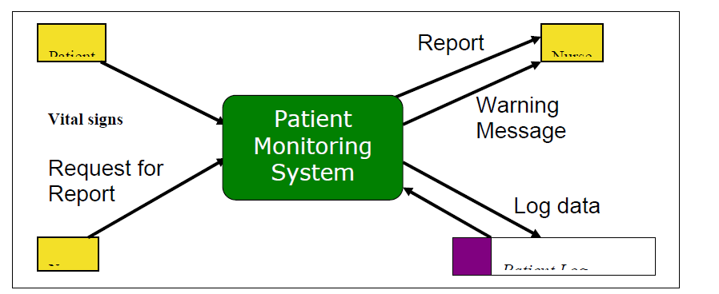



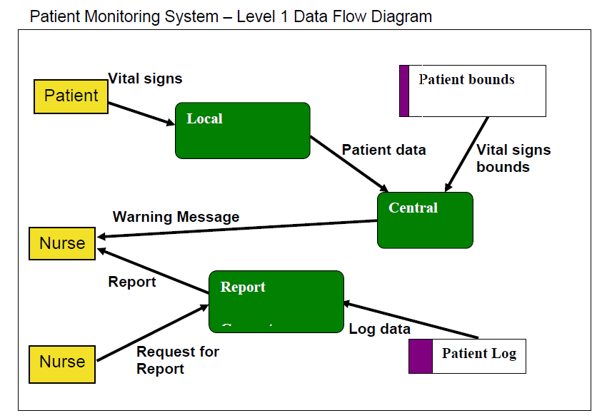

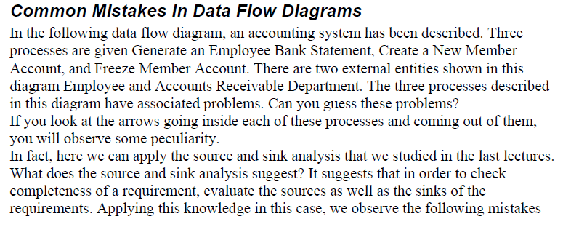

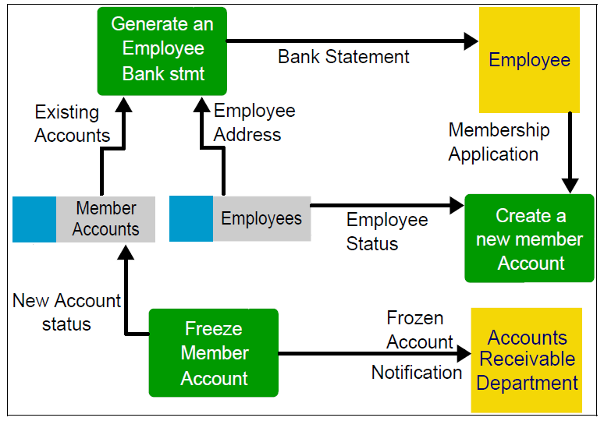

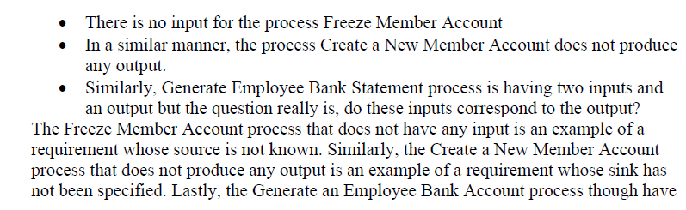

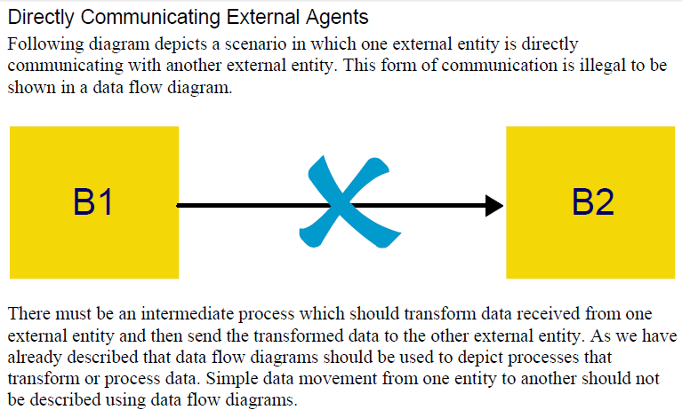

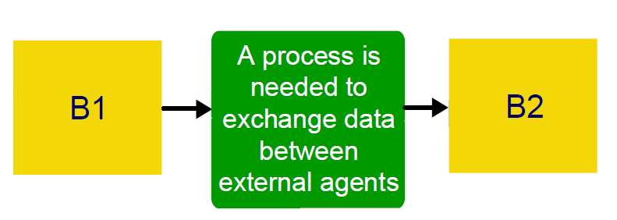

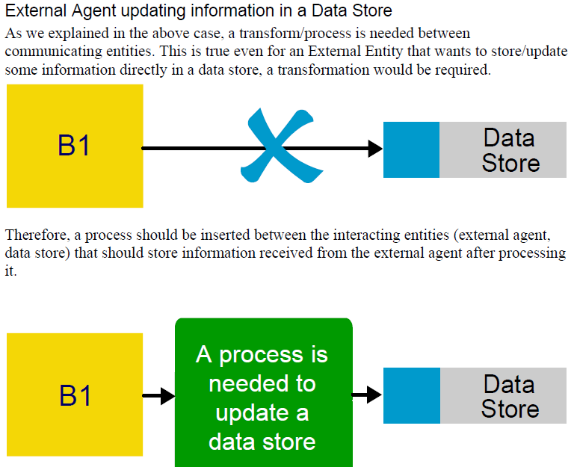

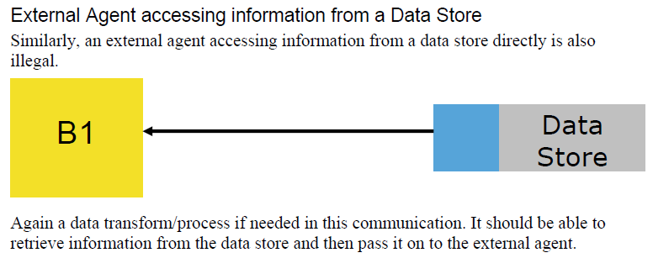

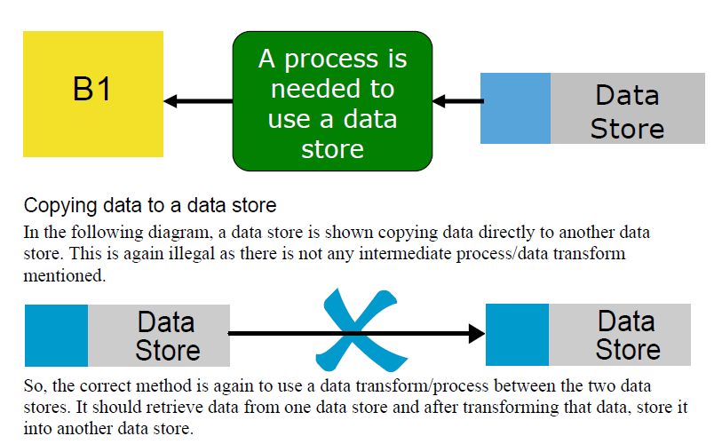

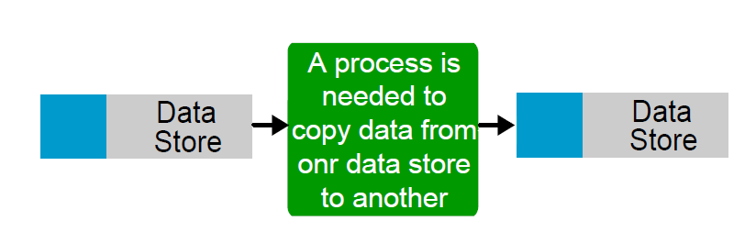

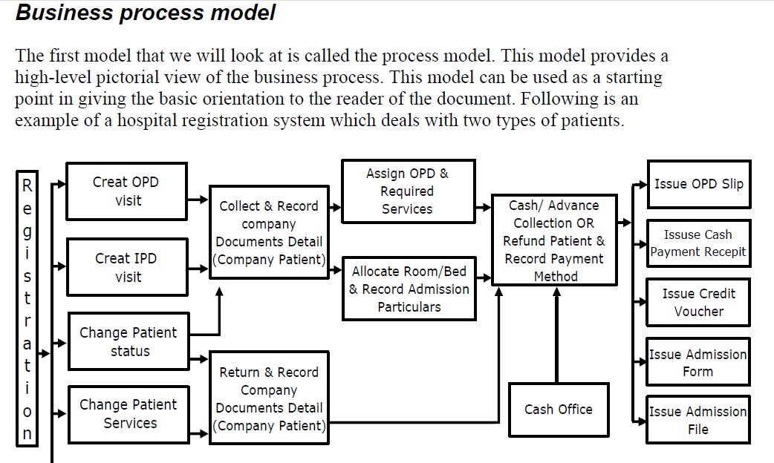

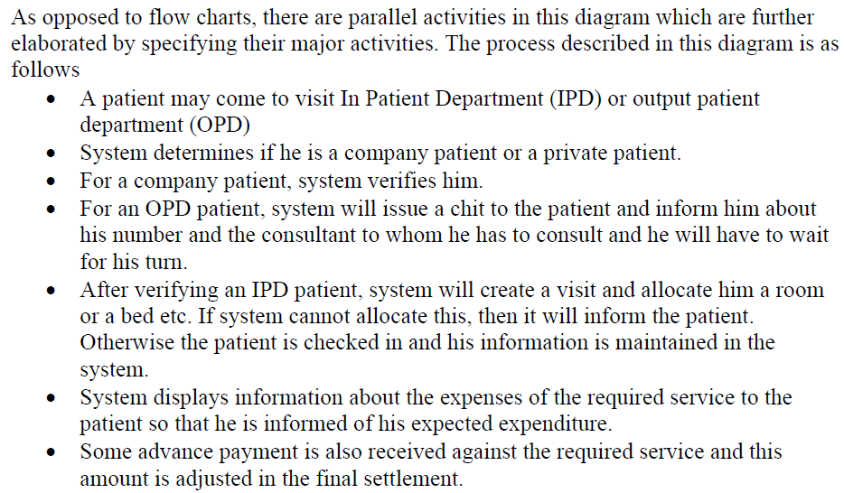

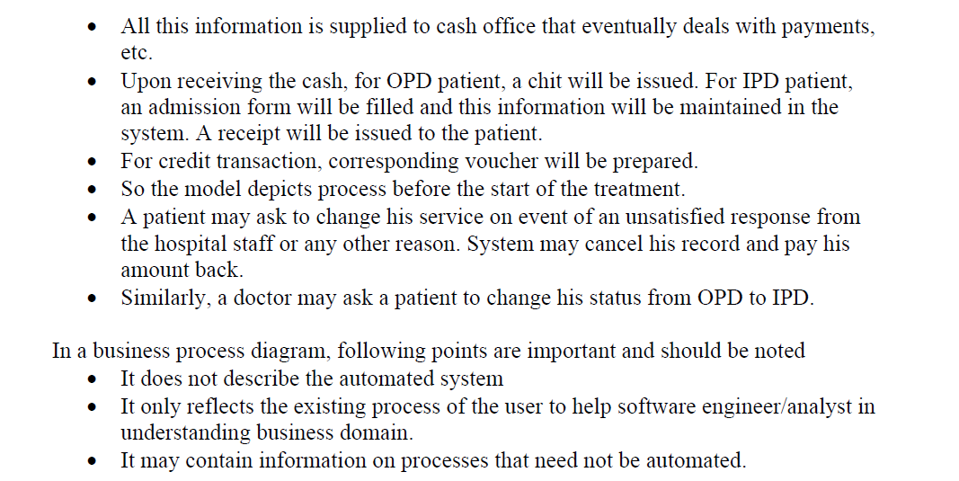

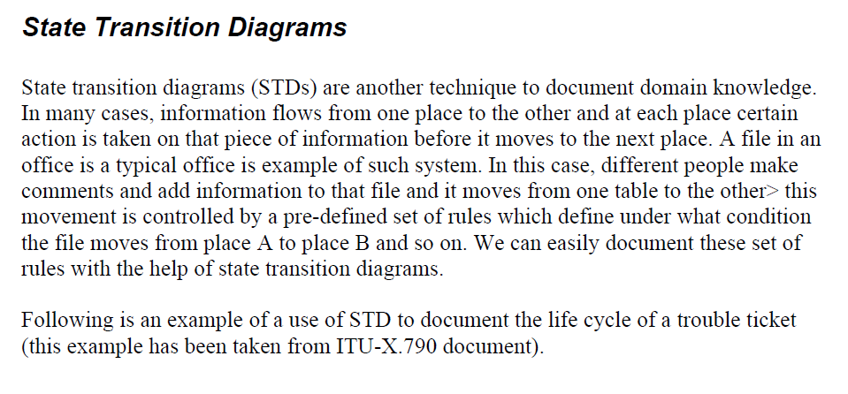

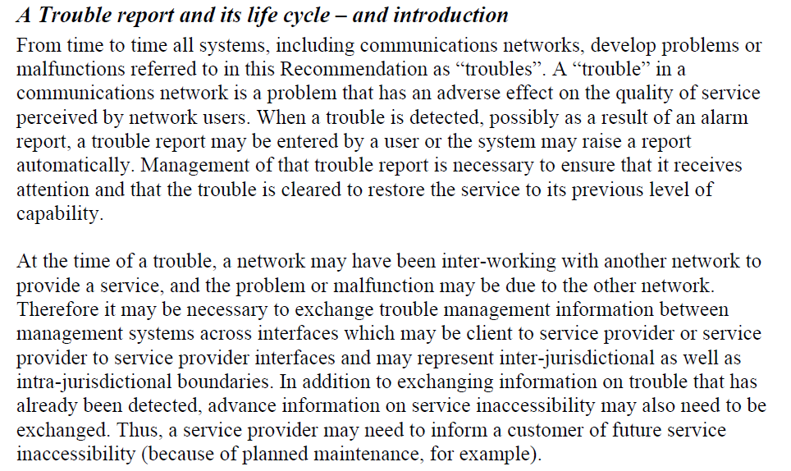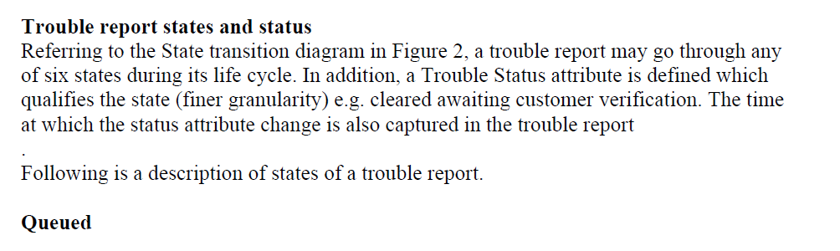

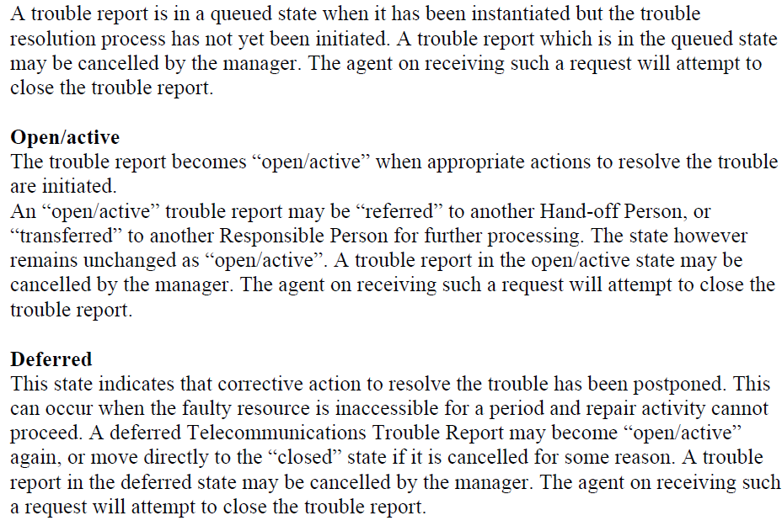

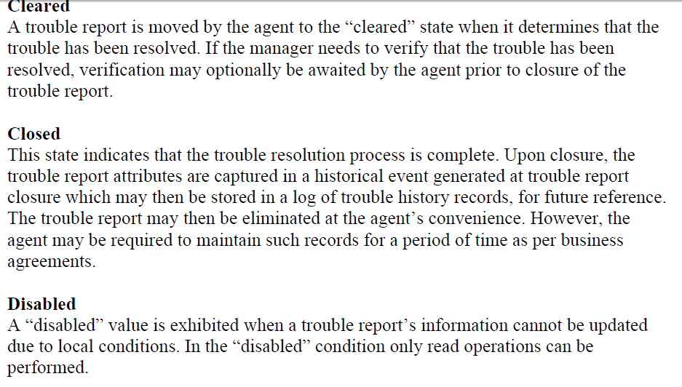

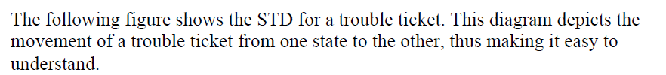

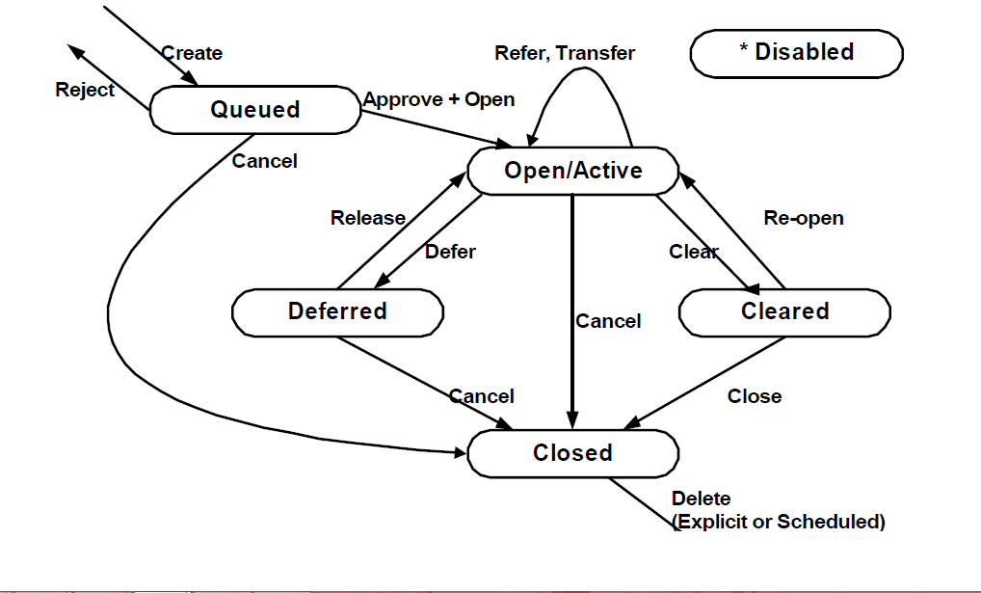

The purpose of Interaction diagrams is to:

• Model interactions between objects

• Assist in understanding how a system (a use case) actually works

• Verify that a use case description can be supported by the existing classes

• Identify responsibilities/operations and assign them to classes

UML provides two different mechanisms to document the dynamic behaviour of the system. These are sequence diagrams which provide a time-based view and

*Collaboration Diagrams* which provide an organization-based view of the system’s dynamics.

**Class Diagram**

A **class diagram** is an illustration of the relationships and source code dependencies among **classes** in the **Unified Modeling Language** (**UML**). In this context, a **class** defines the methods and variables in an object, which is a specific entity in a program or the unit of code representing that entity.

* The main building block in object oriented modeling
* They are used both for general conceptual modeling of the systematics of the application, and for detailed modeling translating the models into programming code
* The classes in a diagram represent both the main objects and/or interactions in the application and the objects to be programmed
* In the diagram these classes are represented with boxes which contain three parts

A class with three sections.

* + The upper part holds the name of the class
  + The middle part contains the attributes of the class
  + The bottom part gives the methods or operations the class can take or undertake
* In the system design of a system, a number of classes are identified and grouped together in a class diagram which helps to determine the static relations between those objects
* With detailed modeling, the classes of the conceptual design are often split in a number of subclasses
* In order to further describe the behavior of systems, these diagrams can be complemented by state diagram or UML state machine
* Also instead of class diagrams, Object role modeling can be used if you just want to model the classes and their relationships

**The class icon**

* **Defines** 
  + **Persistent system state**
  + **System behavior**
* **The class icon has** 
  + **Name**
  + **Attributes**
  + **Operations**
* **It’s a rectangle divided into three compartments.**



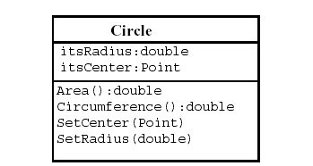

***Structural Modeling:* Core Elements**



**Inheritance –“ISA” or  
“IS A KIND OF” Relationship**

* Each derived class is a special kind of its base class.

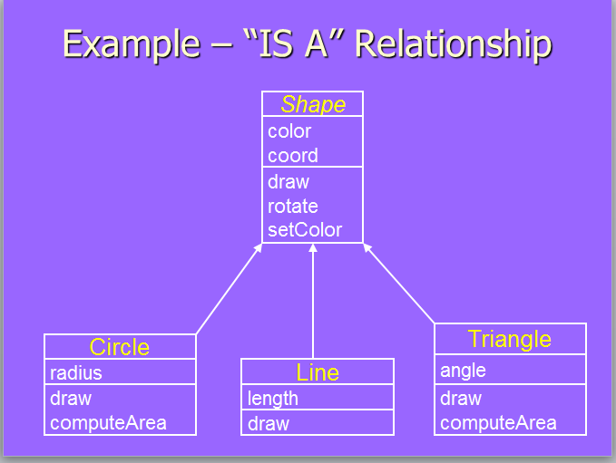

**Concepts Related with Inheritance**

* Generalization
* Subtyping (extension)
* Specialization (restriction)

**Generalization**

In OO models, some classes may have common characteristics.

We extract these features into a new class and inherit original classes from this new class. There are many objects with common characteristics in object model. The common characteristics (attributes and behavior) of all these objects are combined in a single general class. Base class encapsulates the idea of commonality of derived classes. Base class is general class representing common behavior of all derived classes.

This concept is known as Generalization.

It reduces the redundancy and gives us reusability, using generalization our solution becomes less complex.

In generalization there should be "Is a Kind of Relationship" (also called "Is A relationship") between base and child classes.



**Example: Line, Circle and Triangle**

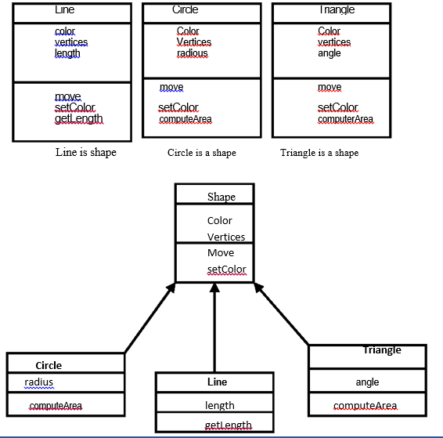

**Common attributes**

Color vertices

**Common behaviour**

Set Color, Move

**Sub-typing & Specialization**

* We want to add a new class to an existing model
* We have developed an existing class hierarchy
* Find an existing class that already implements some of the desired state and behavior.
* Inherit the new class from this class and add unique behavior to the new class.

**Sub-typing (Extension)**

* Sub-typing means that derived class is behaviorally compatible with the base class
* Derived class has all the characteristics of base class plus some extra characteristics.
* Behaviorally compatible means that base class can be replaced by the derived class.

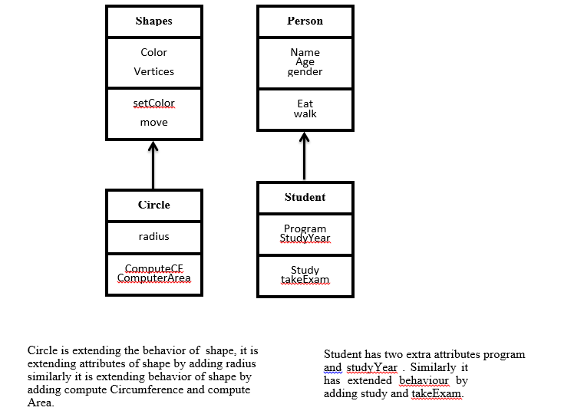

**Specialization (Restriction)**

We want to add a class to existing hierarchy of classes having many similarities to already existing classes but some part of its behavior is different or restricted. In that case we will use the concept of specialization.

Specialization means that derived class is behaviorally incompatible with the base class

Behaviorally incompatibility means that base class can't always be replaced by the derived class

Derived class has some different of restricted characteristics than of base class.

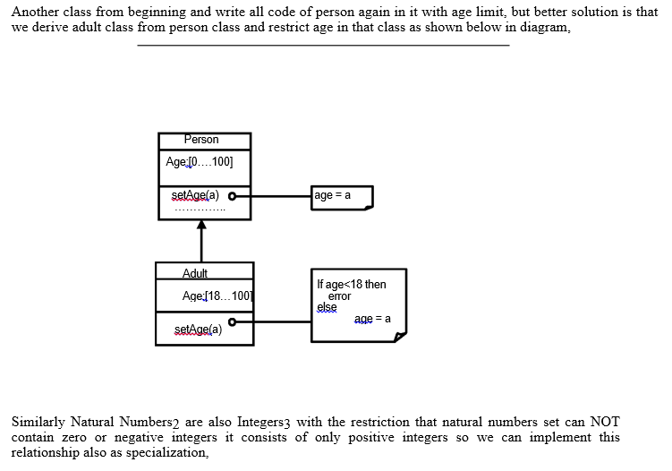

***Structural Modeling:* Core Relationships**









**Kinds of Association**

There are two main types of association which are then further subdivided.

1. Class Association

2. Object Association

**Class Association**

Class association is implemented in terms of Inheritance. Inheritance implements generalization/specialization relationship between objects. Inheritance is considered class association.

• In case of public inheritance it is "IS-A" relationship.

• In case of private inheritance it is "Implemented in terms of" relationship.

This relationship ensures that public members of base class are available to derived class in case of public inheritance.

When we create objects of classes in which we have implemented inheritance relationships we are forcing the inheritance relationship between created objects. In this case the derived class objects will also contain base class objects attributes and methods.

**Object Association**

It is the interaction of standalone objects of one class with other objects of anther class. It can be of one of the following types,

• Simple Association

• Composition

• Aggregation

**Simple Association**

The two interacting objects have no intrinsic relationship with other object. It is the weakest link between objects. It is a reference by which one object can interact with some other object.

Customer gets cash from cashier Employee works for a company

Ali lives in a house

Ali drives a car

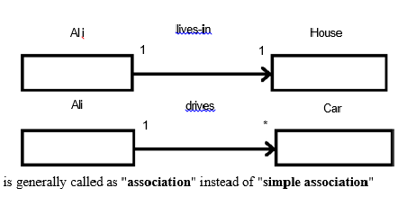

**Kinds of Simple Association**

Simple association can be categorized in two ways,

• With respect to direction (navigation)

• With respect to number of objects (cardinality)

**Kinds of Simple Association w.r.t Navigation**

With respect to navigation association has the following types,

a. One-way Association

b. Two-way Association

**a. One-way Association**

In One way association we can navigate along a single direction only, it is denoted by an arrow towards the server object.

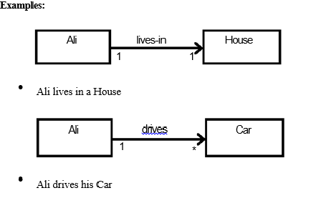

**b. Two-way Association**

In two way association we can navigate in both directions, it is denoted by a line

Between the associated objects

**Examples:**

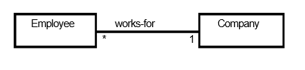

Employee works for company

Company work for employees

**Two-way Association - Example**

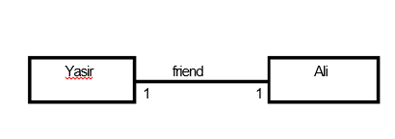

Yasir is a friend of Ali

Ali is a friend of Yasir

**Kinds of Simple Association w.r.t Cardinality**

With respect to cardinality association has the following types,

a. Binary Association

b. Ternary Association

c. N-ary Association

**a. Binary Association**

It associates objects of exactly two classes; it is denoted by a line, or an arrow between the associated objects.

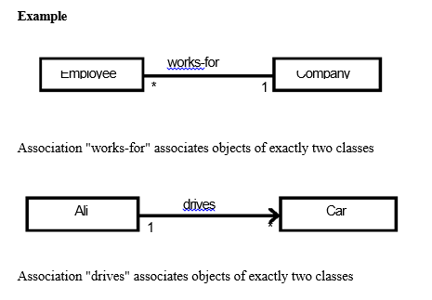

**b. Ternary Association**

It associates objects of exactly three classes; it is denoted by a diamond with lines connected to associated objects.

**Example**

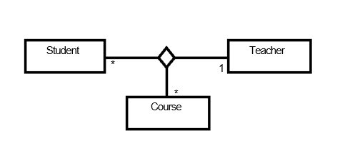Objects of exactly three classes are associated

**c. N-ary Association**

An association between 3 or more classes its practical examples are very rare.

**Composition**

An object may be composed of other smaller objects, the relationship between the "part" objects and the "whole" object is known as Composition, and Composition is represented by a line with a filled-diamond head towards the composer object.

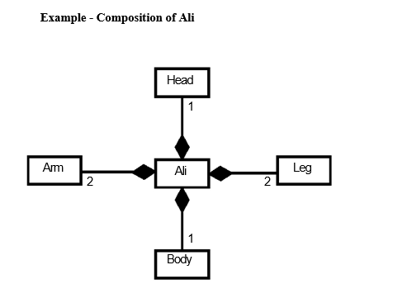

**Example - Composition of Chair**

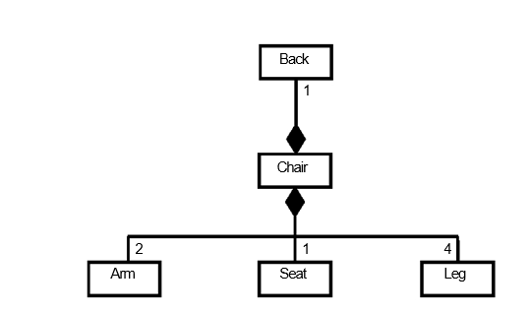

**Composition is stronger relationship:**

Composition is a stronger relationship, because

Composed object becomes a part of the composer

Composed object can't exist independently

**Example I**

Ali is made up of different body parts

They can't exist independent of Ali

**Example II**

Chair's body is made up of different parts

They can't exist independently

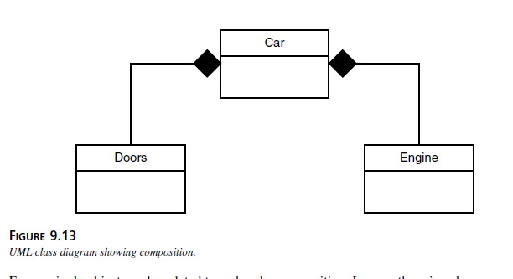

The Sequence Diagram

Let us first look at Sequence Diagrams. These diagrams illustrate how objects interacts with each other

**Aggregation**

[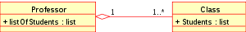](http://en.wikipedia.org/wiki/File:KP-UML-Aggregation-20060420.svg)

Class diagram showing Aggregation between two classes

[*Aggregation*](http://en.wikipedia.org/wiki/Aggregation_(object-oriented_programming)) is a variant of the "has a" association relationship; aggregation is more specific than association. It is an association that represents a part-whole or part-of relationship. As a type of association, an aggregation can be named and have the same adornments that an association can. However, an aggregation may not involve more than two classes; it must be a binary association.

*Aggregation* can occur when a class is a collection or container of other classes, but the contained classes do not have a strong *lifecycle dependency* on the container. The contents of the container are not automatically destroyed when the container is.

In [UML](http://en.wikipedia.org/wiki/Unified_Modeling_Language), it is graphically represented as a *hollow* [diamond shape](http://en.wikipedia.org/wiki/Rhombus) on the containing class with a single line that connects it to the contained class. The aggregate is semantically an extended object that is treated as a unit in many operations, although physically it is made of several lesser objects.

**Aggregation** is a special form of **association**. It is a **relationship** between two classes like **association**, however its a directional **association**, which means it is strictly a one way **association**. It represents a HAS-A **relationship**.

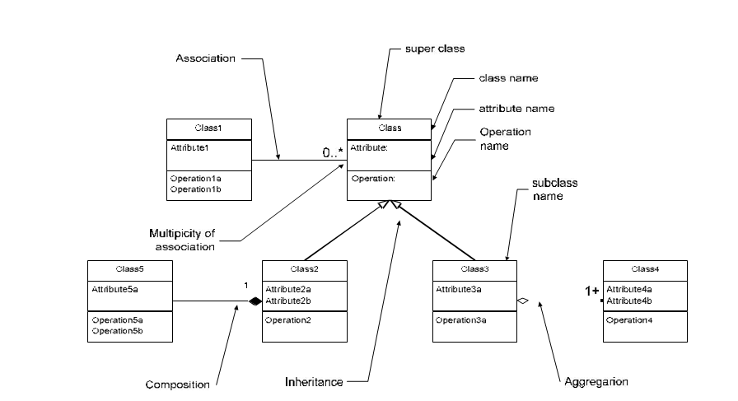

The Notation

Many different notations are used for documenting the object oriented design. Most popular of these include, Rumbaugh, Booch, and Coad, and UML(Unified Modeling Language). We will be using UML to document our design. Although the notation is very comprehensive and detailed, but the key features of this notation are presented in the following diagram.

The Sequence Diagram

Let us first look at Sequence Diagrams. These diagrams illustrate how objects interacts with each other and emphasize time ordering of messages by showing object interactions arranged in time sequence. These can be used to model simple sequential flow, branching, iteration, recursion and concurrency. The focus of sequence diagrams is on objects (and classes) and message exchanges among them to carry out the scenarios functionality. The objects are organized in a horizontal line and the events in a vertical time line.

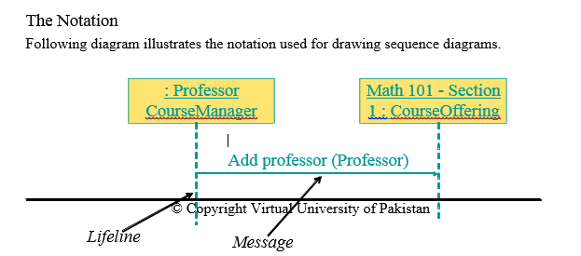

**The diagram's purpose**

The sequence diagram is used primarily to show the interactions between objects in the sequential order that those interactions occur. Much like the class diagram, developers typically think sequence diagrams weremeant exclusively for them. However, an organization's business staff can find sequence diagrams useful tocommunicate how the business currently works by showing how various business objects interact. Besidesdocumenting an organization's current affairs, a business-level sequence diagram can be used as arequirements document to communicate requirements for a future system implementation.

The boxes denote objects (or classes), the solid lines depict messages being sent from one object to the other in the direction of the arrow, and the dotted lines are called life-lines of objects. The life line represents the object’s life during interaction. We will discuss this in more detail later. These concepts are further elaborated with the help of the following sequence diagram.

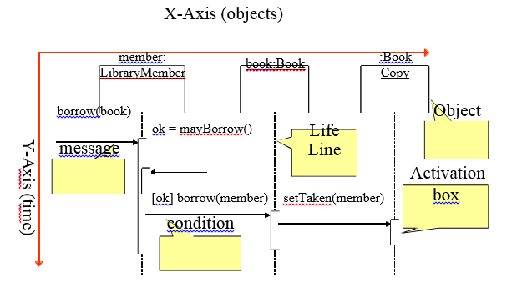

As shown above, in a sequence diagram, objects (and classes) are arranged on the X-Axisn(horizontally) while time is shown on the Y-Axis (vertically). The boxes on the life-line are called activation boxes and show for how long a particular message will be active, from its start to finish. We can also show if a particular condition needs to occur before a message is invoked simply by putting the condition in a box before the message. For example, object *member:LibraryMember* sends a message to object *book:book*  if the value of *ok* is true.

The syntax used for naming objects in a sequence diagram is as follows:

• syntax: [instanceName][:className]

• Name classes consistently with your class diagram (same classes).

• Include instance names when objects are referred to in messages or when several objects of the same type exist in the diagram.

An interaction between two objects is performed as a message sent from one object to another. It is most often implemented by a simple operation call. It can however be an actual message sent through some communication mechanism, either over the network or internally on a computer.If object obj1 sends a message to another object obj2 an association must exist between those two objects. There has to be some kind of structural dependency. It can either be that obj2 is in the global scope of obj1, or obj2 is in the local scope of obj1 (method argument), or obj1 and obj2 are the same object.

A message is represented by an arrow between the life lines of two objects. Self calls are also allowed. These are the messages that an object sends to itself. This notation allows self calls. In the above example, object *member:LibraryMember* sends itself the *mayBorrow* message*.* A message is labeled at minimum with the message name. Arguments and control information (conditions, iteration) may also be included. It is preferred to use a brief textual description whenever an *actor* is the source or the target of a message.

The time required by the receiver object to process the message is denoted by an *activation-box.*

Message Types

Sequence diagrams can depict many different types of messages. These are: synchronous or simple, asynchronous, create, and destroy. The following diagram shows the notation and types of arrows used for these different message types.

Synchronous

Asynchronous

Create

Destroy

**<<create>>**

**<<destroy>**

*Synchronous Messages*

Synchronous messages are “call events” and are denoted by the full arrow. They represent nested flow of control which is typically implemented as an operation call. In case of a synchronous message, the caller waits for the called routine to complete its operation before moving forward. That is, the routine that handles the message is completed before the caller resumes execution. Return values can also be optionally indicated using a dashed arrow with a label indicating the return value. This concept is illustrated with the help of the following diagram.

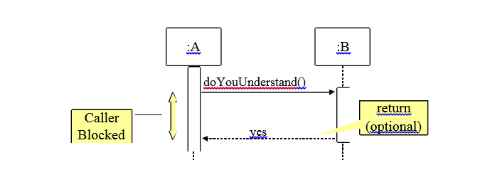

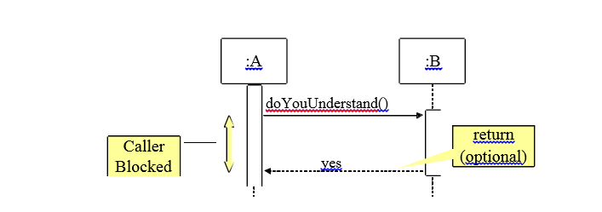

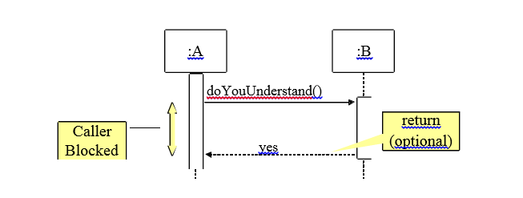

While modeling synchronous messages, the following guidelines should be followed:

• Don’t model a return value when it is obvious what is being returned, e.g.

getTotal()

• Model a return value only when you need to refer to it elsewhere, e.g. as a

parameter passed in another message.

• Prefer modeling return values as part of a method invocation, e.g.

ok = isValid()

*Asynchronous messages*

Asynchronous messages are “signals,” denoted by a half arrow. They do not block the caller. That is, the caller does not wait for the called routine to finish its operation for continuing its own sequence of activities. This occurs in multi-threaded or multi- processing applications where different execution threads may pass information to one another by sending asynchronous messages to each other. Asynchronous messages typically perform the following actions:

• Create a new thread

• Create a new object

• Communicate with a thread that is already running

*Object Creation and Destruction*

An object may create another object via a <<create>> message. Similarly an object may destroy another object via a <<destroy>> message. An object may also destroy itself. One should avoid modeling object destruction unless memory management is critical. The following diagrams show object creation and destruction. It is important to note the impact of these activities on respective life lines.

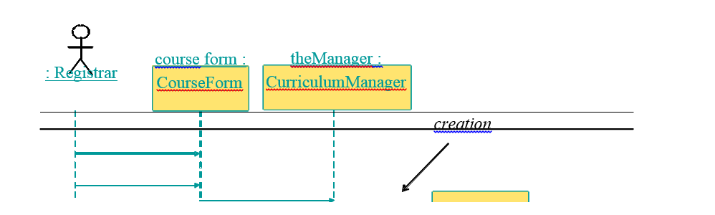





Collaboration diagrams

Collaboration diagrams can also be used to depict the dynamic behaviour of a system. They show how objects interact with respect to organizational units (boundaries!). Since a boundary shapes communication between system and outside world e.g. user interface or other system, collaboration diagrams can be used to show this aspect of the system. The sequence of messages determined by numbering such as 1, 2, 3, 4, … This shows which operation calls which other operation.

Collaboration diagrams have basically two types of components: objects and messages. Objects exchange messages among each-other. Collaboration diagrams can also show synchronous, asynchronous, create, and destroy message using the same notation as used in sequence diagrams. Messages are numbered and can have loops

The following diagrams illustrate the use of collaboration diagrams.

